**Software Requirements Specification**

**for**

Chat Bot for Mutual Fund Company

**Version 0.1 approved**

**Prepared by Mohit Kumar(U101116FCS250)**

**Purandhar Chilukuru(U101116FCS272)**

**Vaibhav Singh(U101116FCS268)**

**Vaishnavi Kattekola(U101116FCS270)**

**Sarthak Tripathi (U101116FCS110)**

**NIIT University Date:10/10/2018**

**Table of Contents**

**Table of Contents ii**

**Revision History ii**

**1. Introduction 1**

1.1 Purpose 1

1.2 Document Conventions 1

1.3 Intended Audience and Reading Suggestions 1

1.4 Product Scope 1

1.5 References 1

**2. Overall Description 2**

2.1 Product Perspective 2

2.2 Product Functions 2

2.3 User Classes and Characteristics 2

2.4 Operating Environment 2

2.5 Design and Implementation Constraints 2

2.6 User Documentation 2

2.7 Assumptions and Dependencies 3

**3. External Interface Requirements 3**

3.1 User Interfaces 3

3.2 Hardware Interfaces 3

3.3 Software Interfaces 3

3.4 Communications Interfaces 3

**4. System Features 4**

4.1 System Feature 1 4

4.2 System Feature 2 (and so on) 4

**5. Other Nonfunctional Requirements 4**

5.1 Performance Requirements 4

5.2 Safety Requirements 5

5.3 Security Requirements 5

5.4 Software Quality Attributes 5

5.5 Business Rules 5

**6. Other Requirements 5**

**Appendix A: Glossary 5**

**Appendix B: Analysis Models 5**

**Appendix C: To Be Determined List 6**

**Revision History**

|  |  |  |  |
| --- | --- | --- | --- |
| **Name** | **Date** | **Reason For Changes** | **Version** |
|  |  |  |  |
|  |  |  |  |

# **Introduction**

## **Purpose**

The purpose of this document is to present a detailed description of the AI Chatbot . It will explain the purpose and features of the Project, the interfaces of the Chatbot, what the Chatbot will do, the constraints under which it must operate and how the Chatbot will react to external stimuli.This proposal is intended for a financial advisory company called Innovative Financials,the idea is to analyze requirements,design and develop AI Chat Bot to augment [indiamf.net](http://indiamf.net/) website.

## **Document Conventions**

The document uses times font for headings (size-14) and arial font for the body (size-11). Hyperlinks are also attached.

## **Intended Audience and Reading Suggestions**

This document is intended for the developers,customer,testers and our professor. The customer would be going through sections such as overall description [2], system features[4], non-functional requirements [5]. The developers would be going through sections such as overall description [2], external interface requirements[3], system features[4], non-functional requirements [5]. the testers would be focusing on the sections like overall description [2], non-functional requirements [5].

## **Product Scope**

The AI Chat Bot will provide the ability to transact mutual funds online, provide customized fund advisory, market situation, performance statistics of mutual funds in customer portfolio. The company is looking to expand its digital operations and as part of expansion it is also looking to introduce this software.

## **References**

If you want to know about what is a Chatbot you can refer to <https://en.wikipedia.org/wiki/Chatbot>.

For more info on AI visit <https://en.wikipedia.org/wiki/Artificial_intelligence>

IEEE. *IEEE Std 830-1998 IEEE Recommended Practice for Software Requirements Specifications.* IEEE Computer Society, 1998.

# **Overall Description**

## **Product Perspective**

This project will be integrated to company’s website. The AI Chatbot will be invocable from the site. It will provide information about account balances, transaction history and capital gain statements. Product will help in expanding companies digital operations.

## Product Function

The chatbot will be helping the company to go fully digitized and decrease the manual work of its employees.The function of chatbot will be to provide an automated 24/7 support to the users like helping them in completing a transaction, providing information about mutual funds, market scenario.

## **User Classes and Characteristics**

The user is expected to be Internet literate and be able to use a chat bot. The main screen of the indiamf Website will have the chat bot and user login.The user should able to provide the necessary information to respond to a query.The chatbot is specially made for mutual fund website so the bot will not able to entertain queries on some other subject.It will provide suggestions like did you mean SIP? if the queries are not based on the mutual fund.

The detailed look of these pages is in section 3.1 below.There are three types of users :Registered and unregistered users and Admin.The use case below shows the user classes.

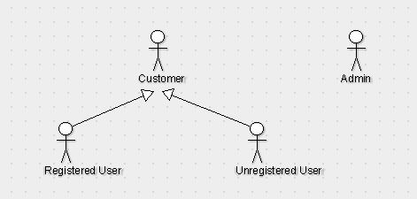

## **Operating Environment**

The chatbot will be integrated into the Indiamf website. Since it is based on Google API it can work across all platforms.The Bot can simply work on any web browser.So it does not require any specific hardware or operating System.

## **Design and Implementation Constraints**

The access to the source code of the website is not available due to their corporate policies , so integration of the chatbot with the website will be done by the company itself.

## **User Documentation**

The chatbot itself it will provide external support to any user who visits the website by providing list of steps a user needs to get himself registered on the website and become a member. After the user gets logged on it will display every information regarding his account and list of things which he can do.

## **Assumptions and Dependencie**s

**2.7.1** Since we cannot integrate the chat bot directly into the website because the company uses a third-party website for their online operations, we are assuming that the chatbot can be integrated into their website if it can be integrated to a test website which will be provided by the company.

**2.7.2**

We are provided with dummy data variables .So,we are assuming that the dummy data variables and original data variables will be same and if the original data variable is different

then the chatbot may not be able to respond to the query about that variable.

# **External Interface Requirements**

## **User Interfaces**

The user interface will look some like this

## 

The chatbot will be available for registered customers as well as the customers who are not registered with the company. The unregistered will be have a conversation with generic Chatbot which guides them through registration process

## **Hardware Interfaces**

The AI bot will work across any operating system which has a web browser and any browser which supports HTML,CSS and JavaScript.

## **Software Interfaces**

**Framework for chatbot:** Dialog Flow

**Website**

**Frontend**:HTML,CSS,JavaScript

**Backend**:JDBC

**Website Framework**:Spring Boot

## **Communications Interface**

After the building the chatbot and testing it using a temporary website and a temporary account, the extension is handed over to the vendor who developed the production website. The integration of the Chatbot will be done by them.The Chatbot will also use Google Email services for authentication of the users.

# **System Features**

**4.1 Handle different type of users efficiently.**

4.1.1 Description and Priority

The bot will provide information for two types of user:

1. For the end user who are not part of the website and have visited the website first time,it will provide information that how to get yourself registered on the website and become a member of indiamf.
2. For the end user who are already the part of organization will get additional features like checking their balance,getting a direct link to get their kyc done and other function features.

4.1.2 Stimulus/Response Sequences

If the user is has a query regarding mutual funds,the bot will respond according to that using a google search but if the user has query other than mutual funds information then the bot will provide suggestions of queries regarding mutual funds.

4.1.3 Functional Requirements

Requirement 1: Authentication of the user

It is required to access some features like check account balance

refers to login action of the registered user(actor) in the use case.

**4.2 Compatible to different screen resolutions and browsers.**

4.2.1 Description and Priority

The chatbot should be platform independent and should not depend on the type of system.

4.2.2 Stimulus/Response Sequences

The bot will be able to adapt to different color schemes and screen sizes on its own since the website itself is dynamic.

4.2.3 Functional Requirements

Requirement 1: The website used for integration of the bot should be dynamic and responsive.

**4.3. Multiple language support**

4.3.1 Description and Priority

The chatbot will be able to have conversation in multiple languages like English, Hindi, and Telugu.

4.3.2 Stimulus/Response Sequences

The default language is English. So, the user has to change language settings for translation and the bot will respond according to that.

4.3.3 Functional Requirements

Requirement 1: Google Translator API is required

**4.4. Session ending**

4.4.1 Description and Priority

If user is logged in should be logged off on exit.

4.4.2 Stimulus/Response Sequences

If the user exits the Browser without logging out than bot should automatically log out.

4.4.3 Functional Requirements

Requirement 1: Session Management

**4.5. Graceful interaction**

4.5.1 Description and Priority

The user can have friendly conversation with bot using words like hi,hello,how are you?, etc.

4.5.2 Stimulus/Response Sequences

User should be able to gracefully exit the session by using key words like bye, logout etc**.**

4.5.3 Functional Requirements

Requirement 1: SmallTalk Customization

**4.6. Invokable from Indiamf.net website**

4.6.1 Description and Priority

The chatbot will be invokable from the company’s official website and the integration should be seamless.

4.6.2 Stimulus/Response Sequences

The Chat bot will be invoked from the website using a chat window at bottom right side of the window

4.6.3 Functional Requirements

Requirement 1: Javascript

**4.7. Have a persona.**

4.7.1 Description and Priority

The chatbot will have a personality as well as a name. The user will be able to refer the Chatbot with the name.

4.7.2 Stimulus/Response Sequences

When ever the user call the Chatbot with its name chatbot should able to respond accordingly. The Chatbot should have a personality which can be shown by the way he answers the question.

4.7.3 Functional Requirements

Requirement 1: The chatbot should be able to recognize its name whenever it is used in an conversation

**4.8. Authenticate user based on Indiamf.net credentials.**

4.8.1 Description and Priority

The Chatbot will be able to authenticate user based on their credentials and provide them with personalized results.

4.8.2 Stimulus/Response Sequences

Whenever the user is logged in the chatbot should be able to recognize the user based on his credentials.

4.8.3 Functional Requirements

Requirement 1: Database access

Requirement 2: Google email Services

**4.9 Provide account balance.**

4.9.1 Description and Priority

The chatbot will provide user with his account details after the user has logged in.

4.9.2 Stimulus/Response Sequences

When user is logged in and asks for account balance than it should be provided.

4.9.3 Functional Requirements

Requirement 1: Database access

**4.10 Provides portfolio performance metrics.**

4.10.1 Description and Priority

It will provide portfolio performance matrix like investment value,performance of the shares,Details about market leaders.

4.10.2 Stimulus/Response Sequences

The bot will analyse the user's account through the number of mutual funds, gains and loses to provide a proper graphical representation of his investments

4.10.3 Functional Requirements

Requirement 1: NSE API

Requirement 2: Machine learning

Requirement 3: Google analytics API

**4.11 Give transaction status.**

4.11.1 Description and Priority

The chatbot will able to provide user with his transaction status about the investment in mutual funds

4.11.2 Stimulus/Response Sequences

When ever stock value of user changes user will be notified by the chatbot.

4.11.3 Functional Requirements

Requirement 1: NSE API

**4.12 Provide links for KYC/eKYC**

4.12.1 Description and Priority

The chatbot will provide users with KYC links which will automate the KYC process for the company.

4.12.2 Stimulus/Response Sequences

When user wants to do KYC he will be provided with the LinksFor it.The user can also check his KYC status using chatbot.

4.12.3 Functional Requirements

none

**4.13. Guidance about registration**

4.13.1 Description and Priority

Should be able to provide guidance on how to become a customer of Innovative Financials for non customers

4.13.2 Stimulus/Response Sequences

The bot will provide steps for the registration,schemes and benefits to the customer for being associated with the company.

4.13.3 Functional Requirements

none

**4.14. List of unanswered questions**

4.14.1 Description and Priority

Botshould maintain a list of unanswered queries provided with an answer must be configurable to update responses and answer those queries in future.

4.14.2 Stimulus/Response Sequences

If bot is not able to answer the question he ask the customer to contact customer support and the question will be recorded.

4.14.3 Functional Requirements

Requirement 1: database

**4.15 Secure communication**

4.15.1 Description and Priority

The communication between user and bot should be secure and safe. Details like transactions are answered by the company employees through mail and bot provides the utmost time of mail to be received.

4.15.2 Stimulus/Response Sequences

The bot provides end to end encryption.

4.15.3 Functional Requirements

Requirement 1:Homomorphic encryption

Requirement 2: Attribute based encryption

Requirement 3:CryptDB

# **Other Nonfunctional Requirements**

## **Performance Requirements**

The Chat bot will use Google server for better performance and for handling concurrent users. NSE APIs will be used to provide real time market scenarios.

## **Safety Requirements**

The Chatbot will only be used to provide information to the customer.The Chatbot will not be used to perform transactions.For ex. : The customer can use chatbot to know his stock value or balance but can’t perform transactions.The chatbot can only provide the users with steps to perform transactions.

## **Security Requirements**

Since we are using Dialog Flow framework which uses Google API.The Google APIs terms of services will applicable here. Please refer to the Link for more information <https://developers.google.com/terms/>

## **Software Quality Attributes**

The Chatbot has Small-Talk feature which gives the users experience of a real conversation.The chatbot uses API the responses will much faster.The chatbot uses machine learning to respond to new queries.The Chatbot is compatible across all platform which have any browser.

## **Business Rules**

The customers will only be able to ask queries from the chatbot.Developers will be able to update or create new queries as wells as responses to make it more user friendly.

Employees of the company will able to monitor the transactions details and monitor issues related to users.

**Appendix A: Glossary**

1. **API ( Application programming Interface)**: an application programming interface is a set of subroutine definitions, communication protocols, and tools for building software.
2. **NSE (National Stock Exchange):** Demutualized electronic exchange in the country.
3. **JDBC(Java Database Connectivity)**
4. **HTML(Hypertext Markup Language)**
5. **CSS(Cascading Style Sheets)**

**Appendix B: Analysis Models**

**Use Case Diagram for the Chat Bot** 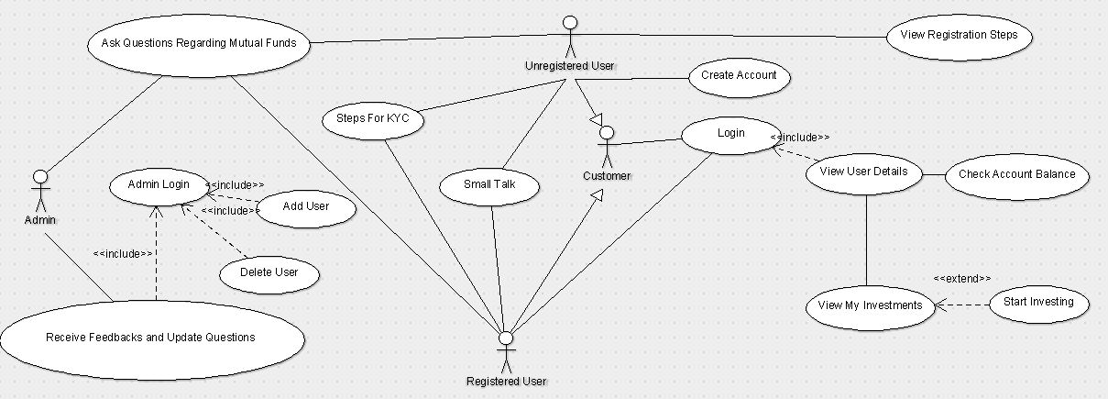

**Appendix C: To Be Determined List**